How to Program a Micro:bit Using an iPad

This document provides step-by-step instructions for programming a Micro:bit using an iPad. You will need a Micro:bit, a USB cable, an iPad, the Micro:bit app for iOS, and optionally, a battery pack.

# Step 1: Install the Micro:bit App

1. Open the App Store on your iPad.  
   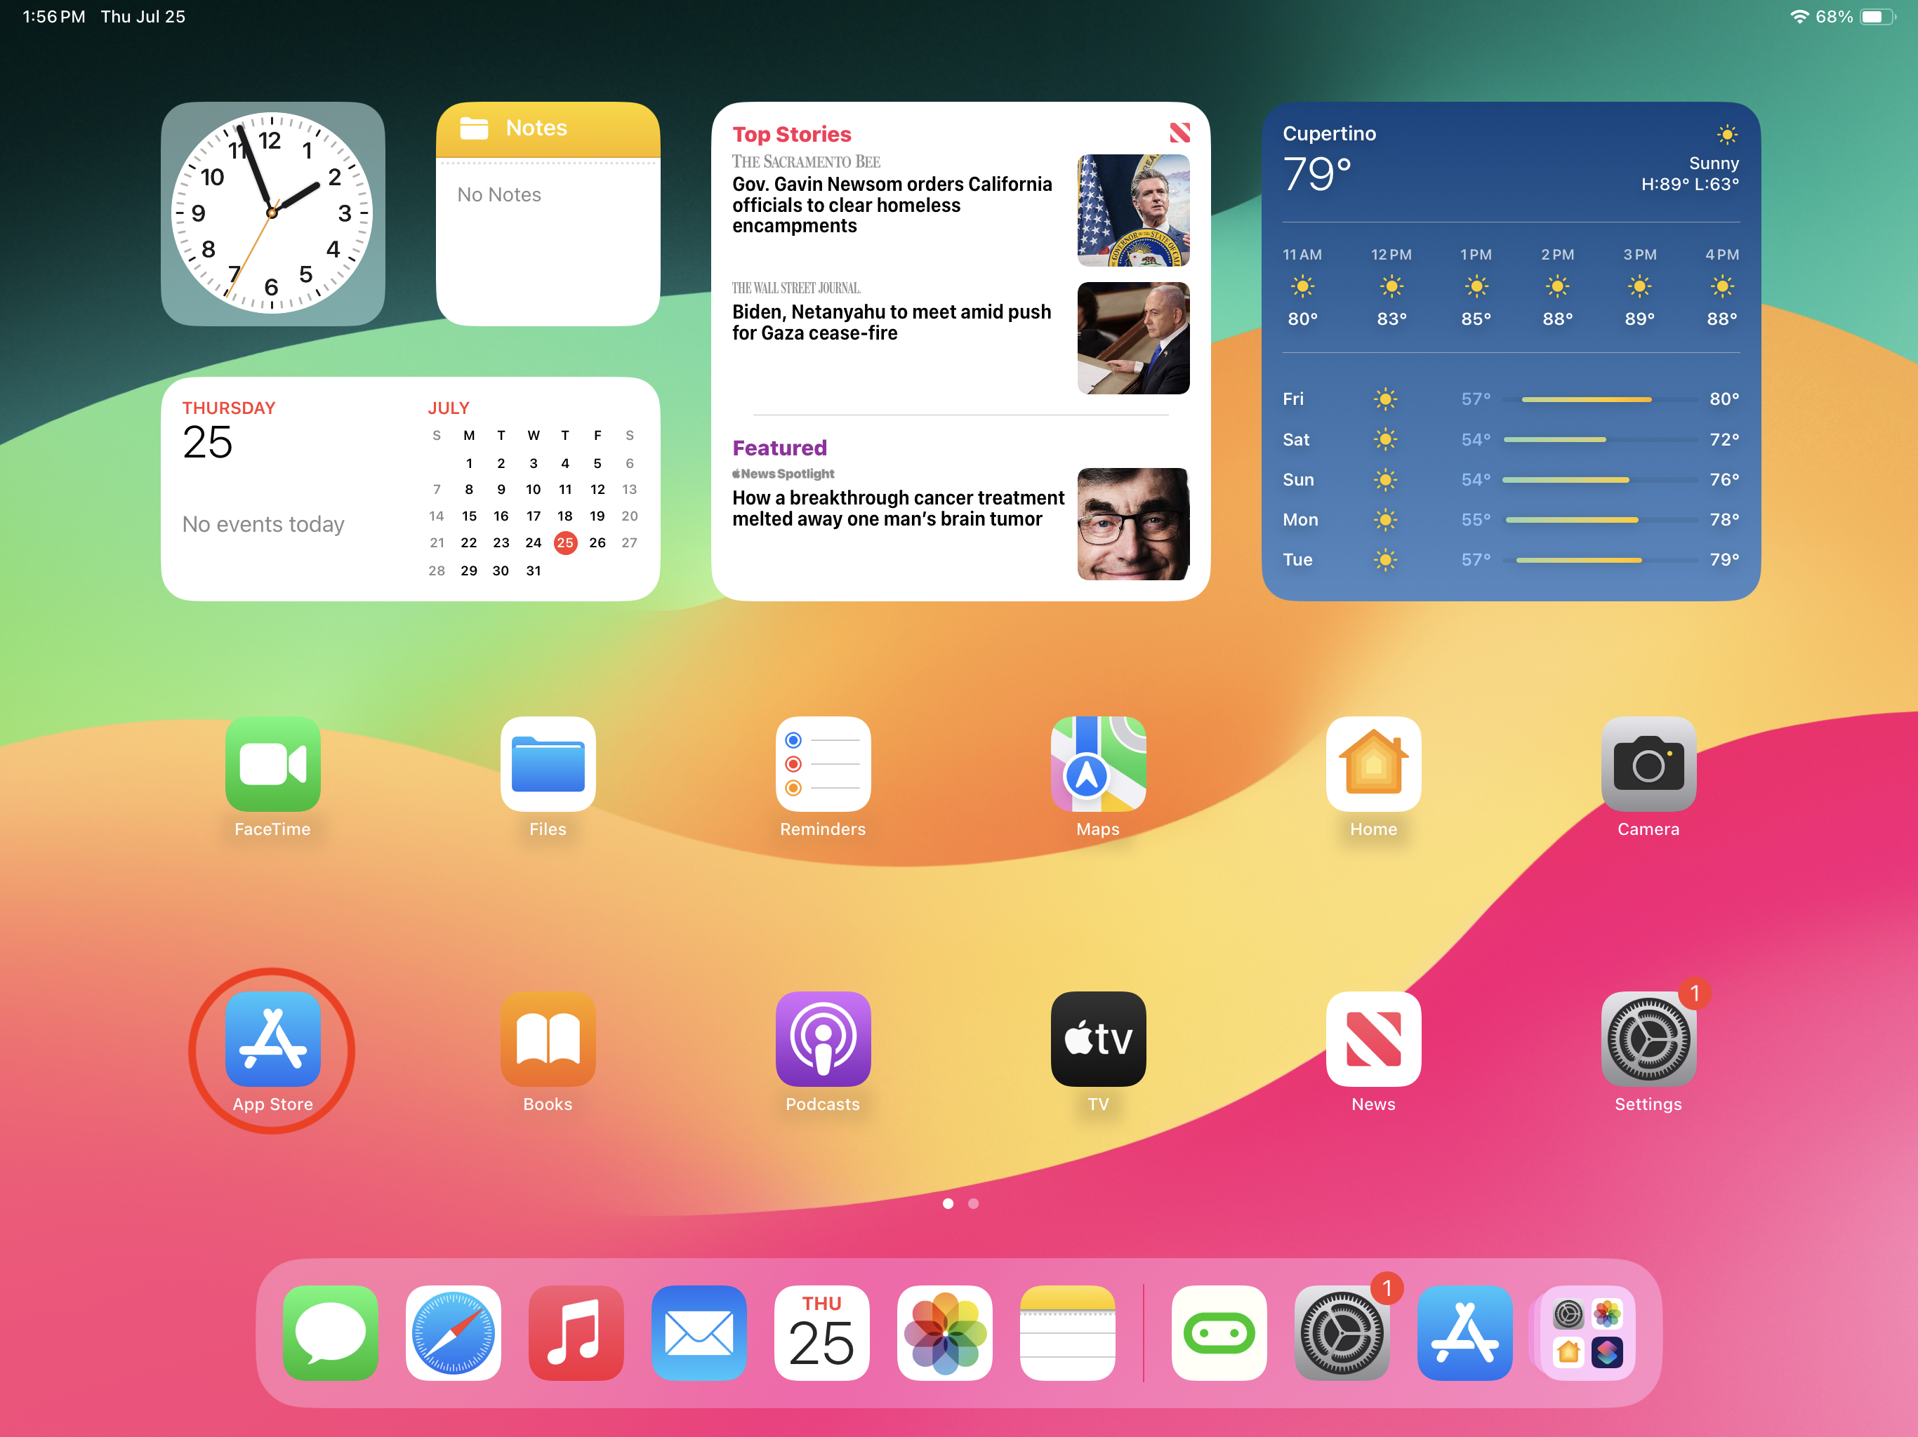

2. Search for 'Micro:bit'.  
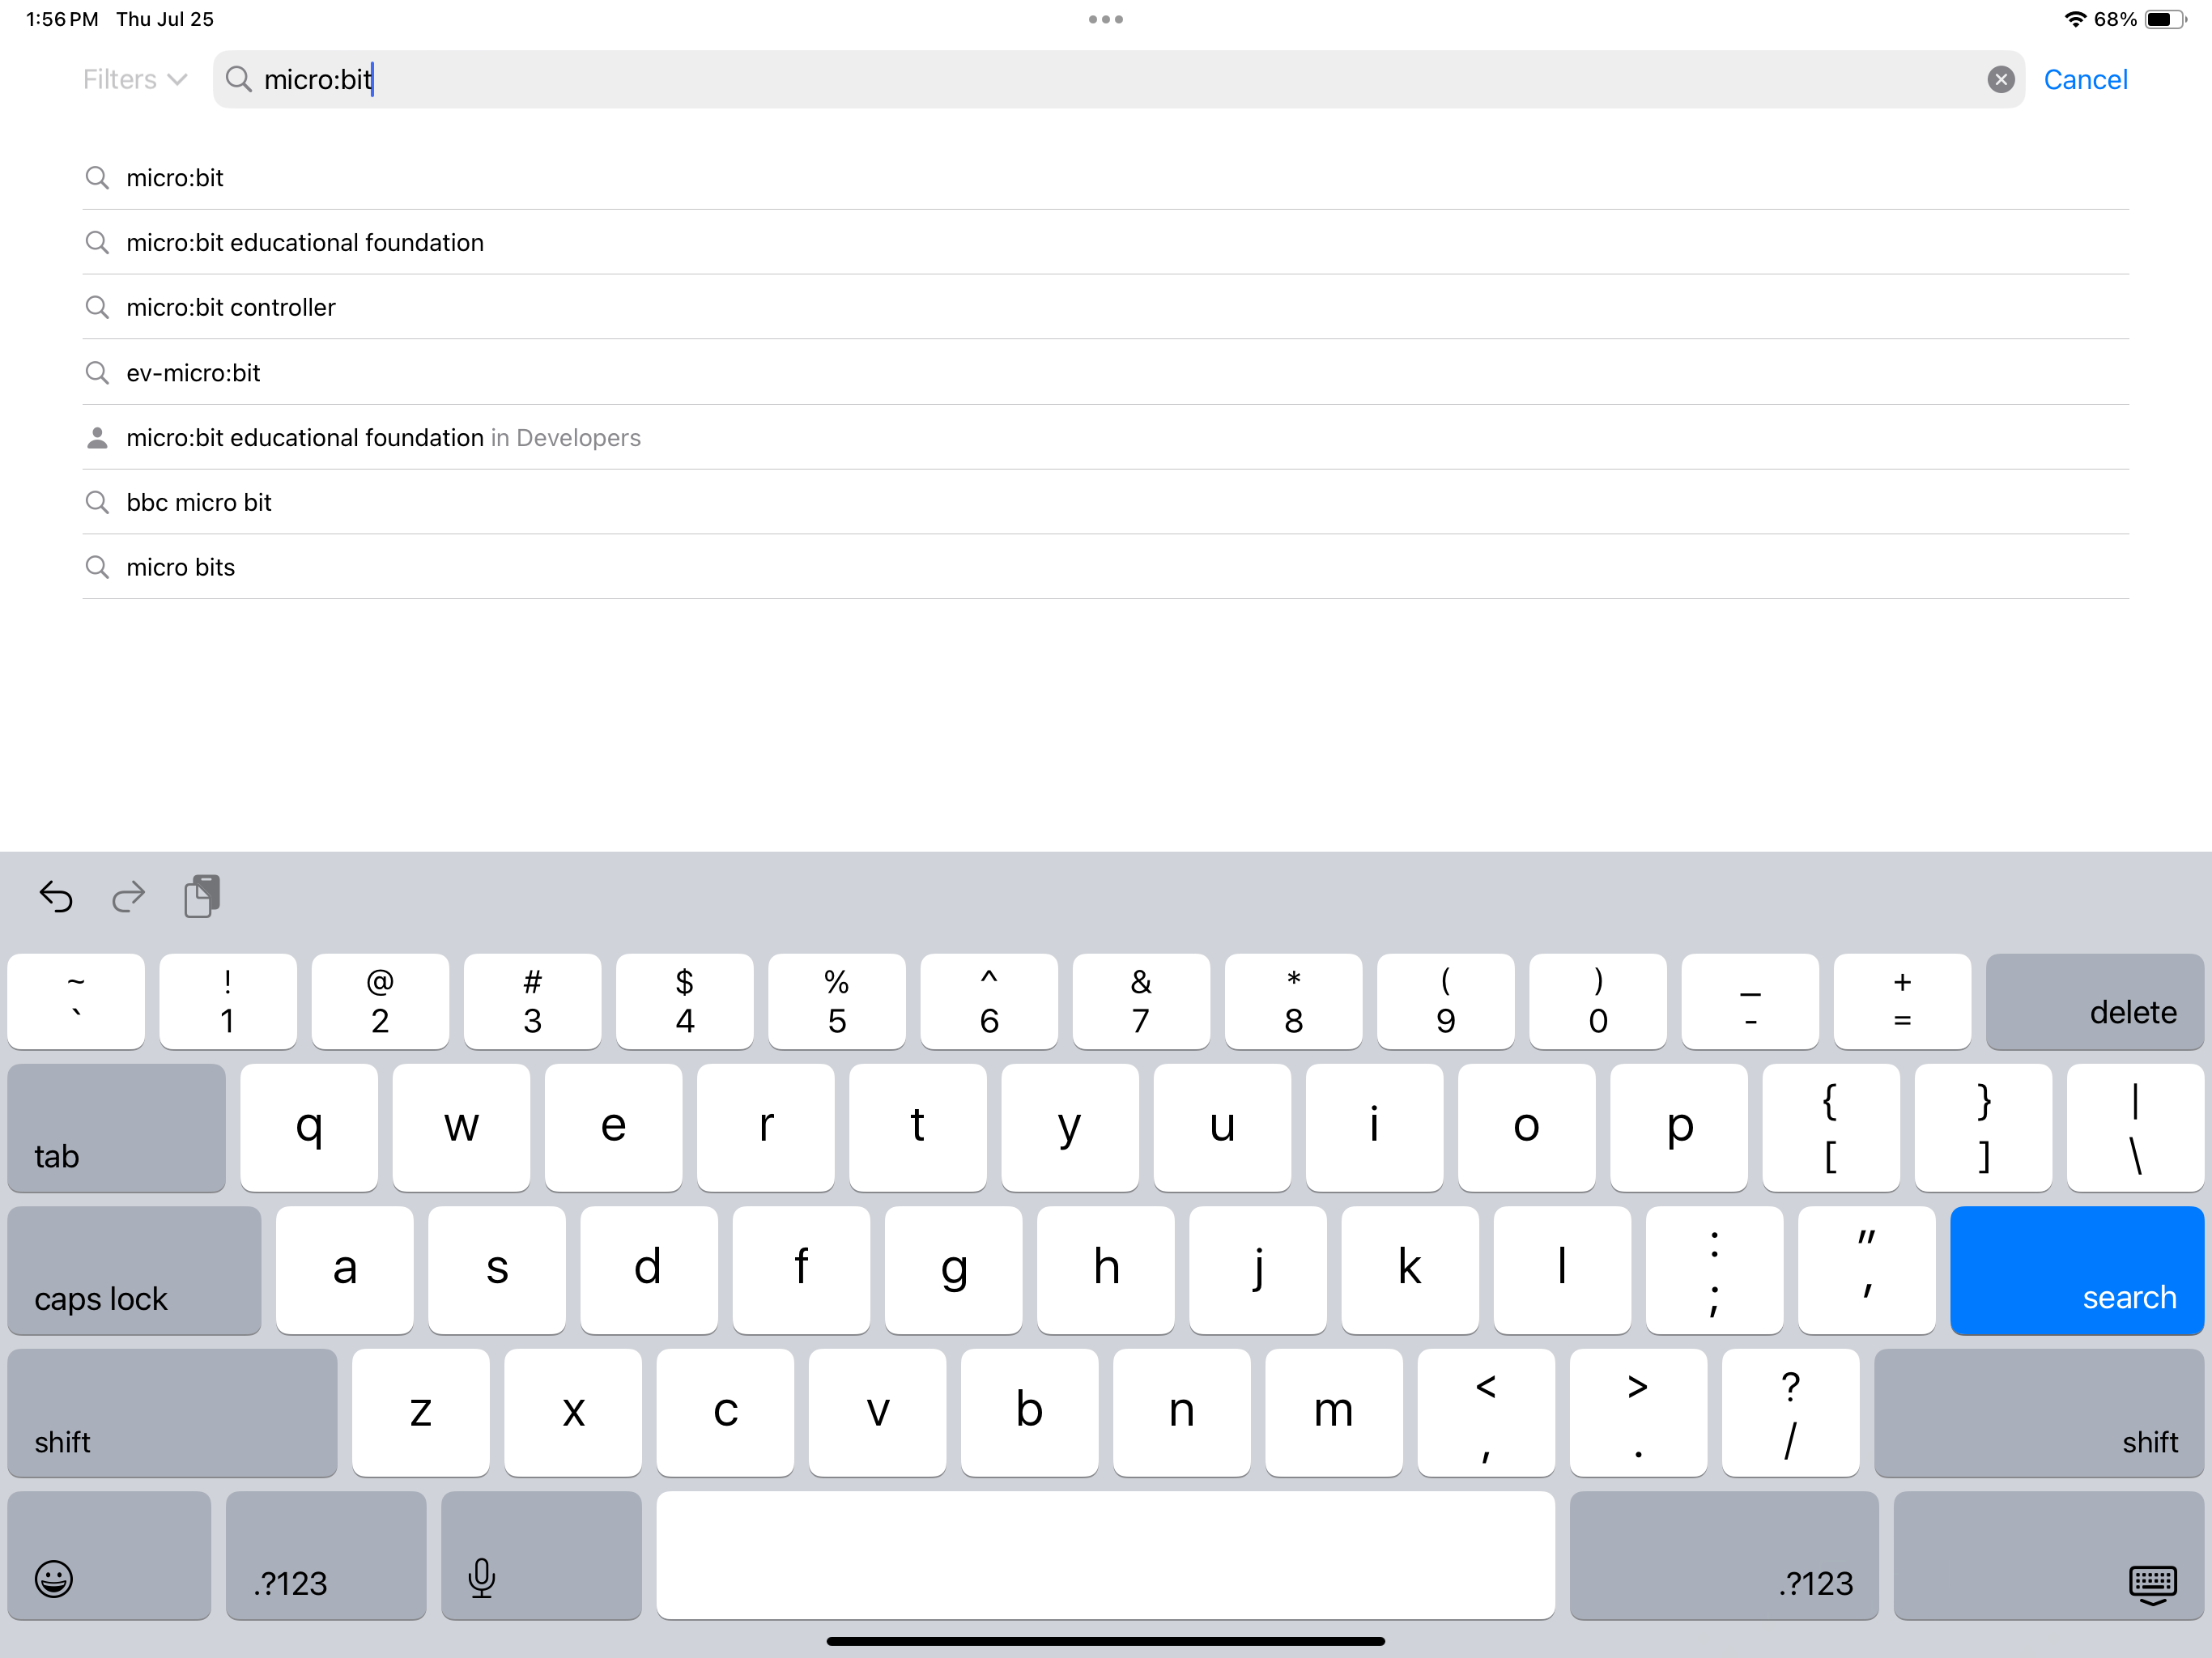

3. Download and install the official Micro:bit app.  
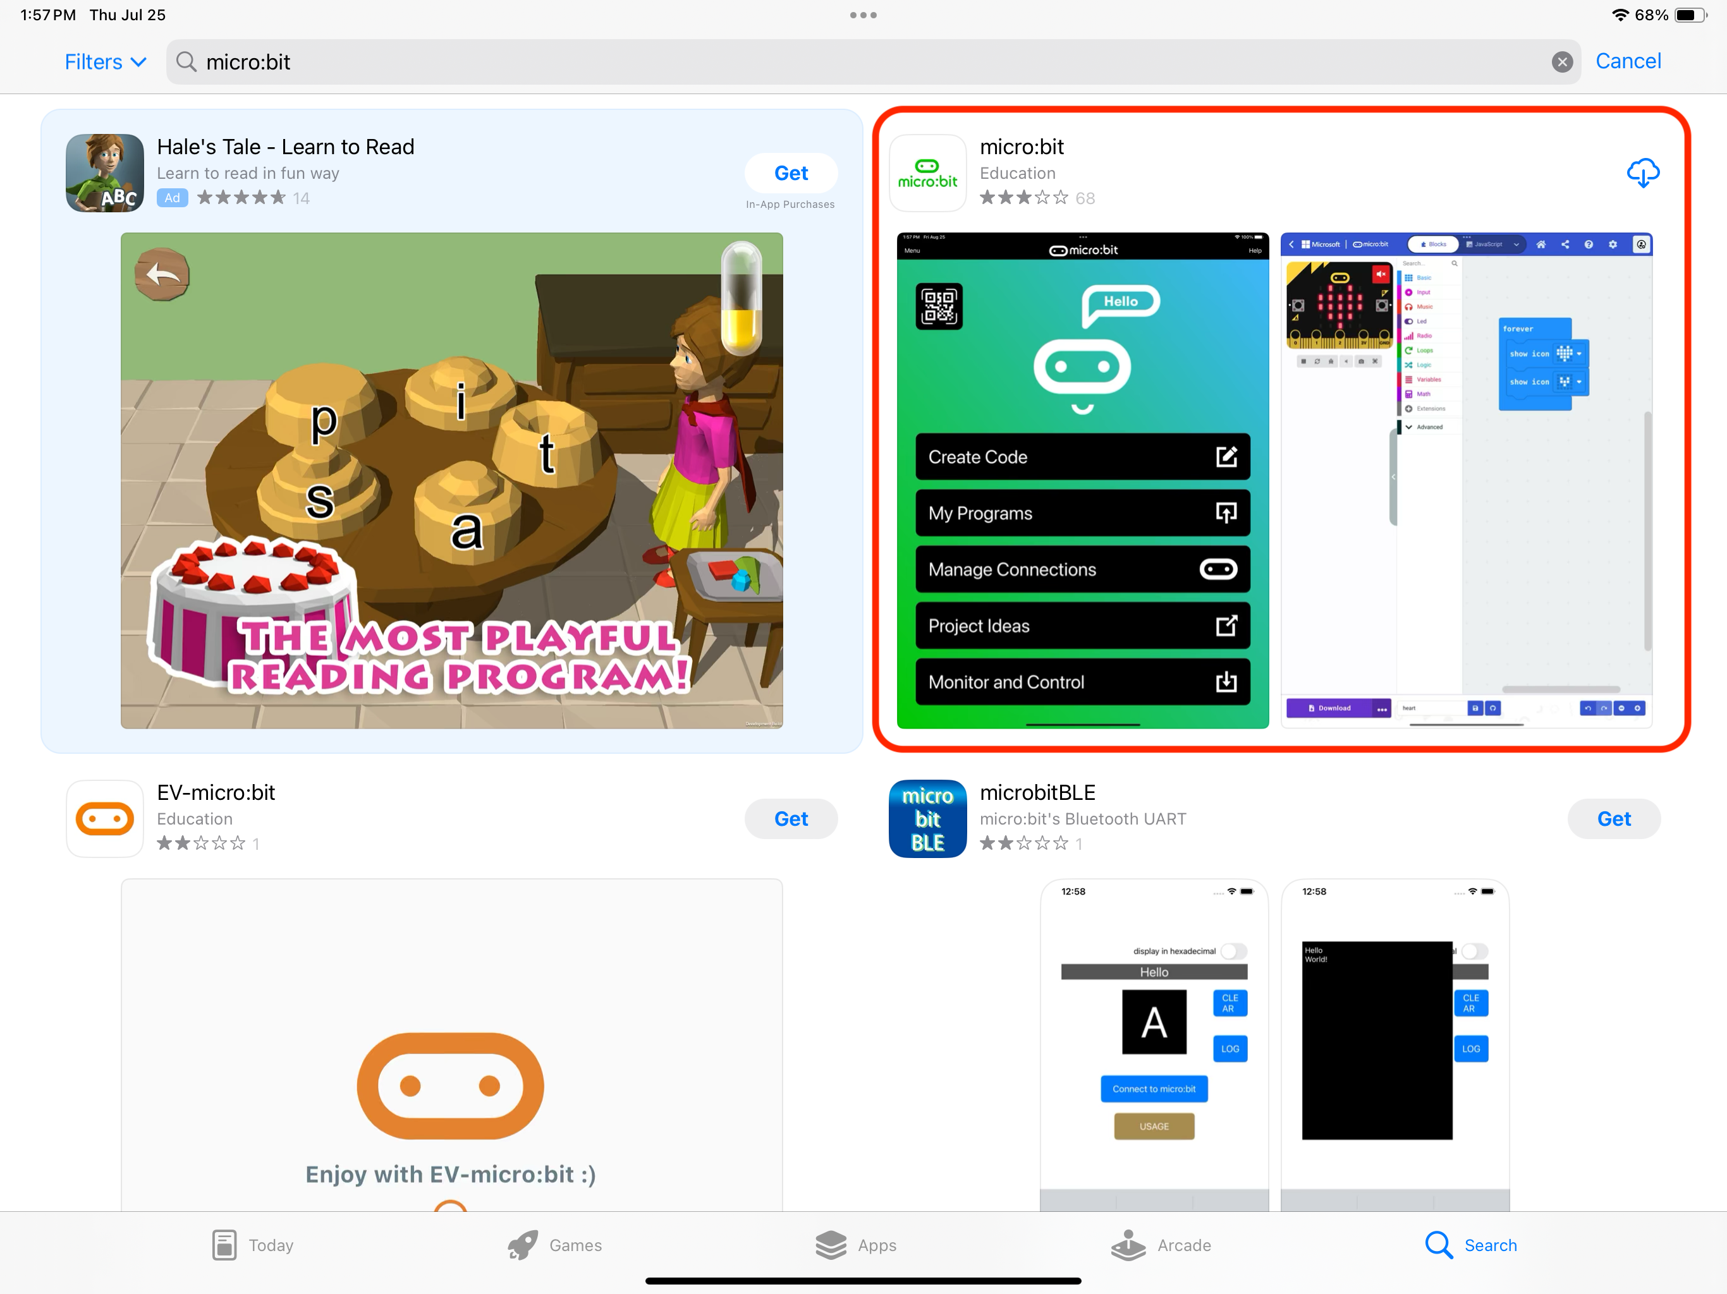

# Step 2: Connect Your Micro:bit

1. Open the Micro:bit app on your iPad.  
   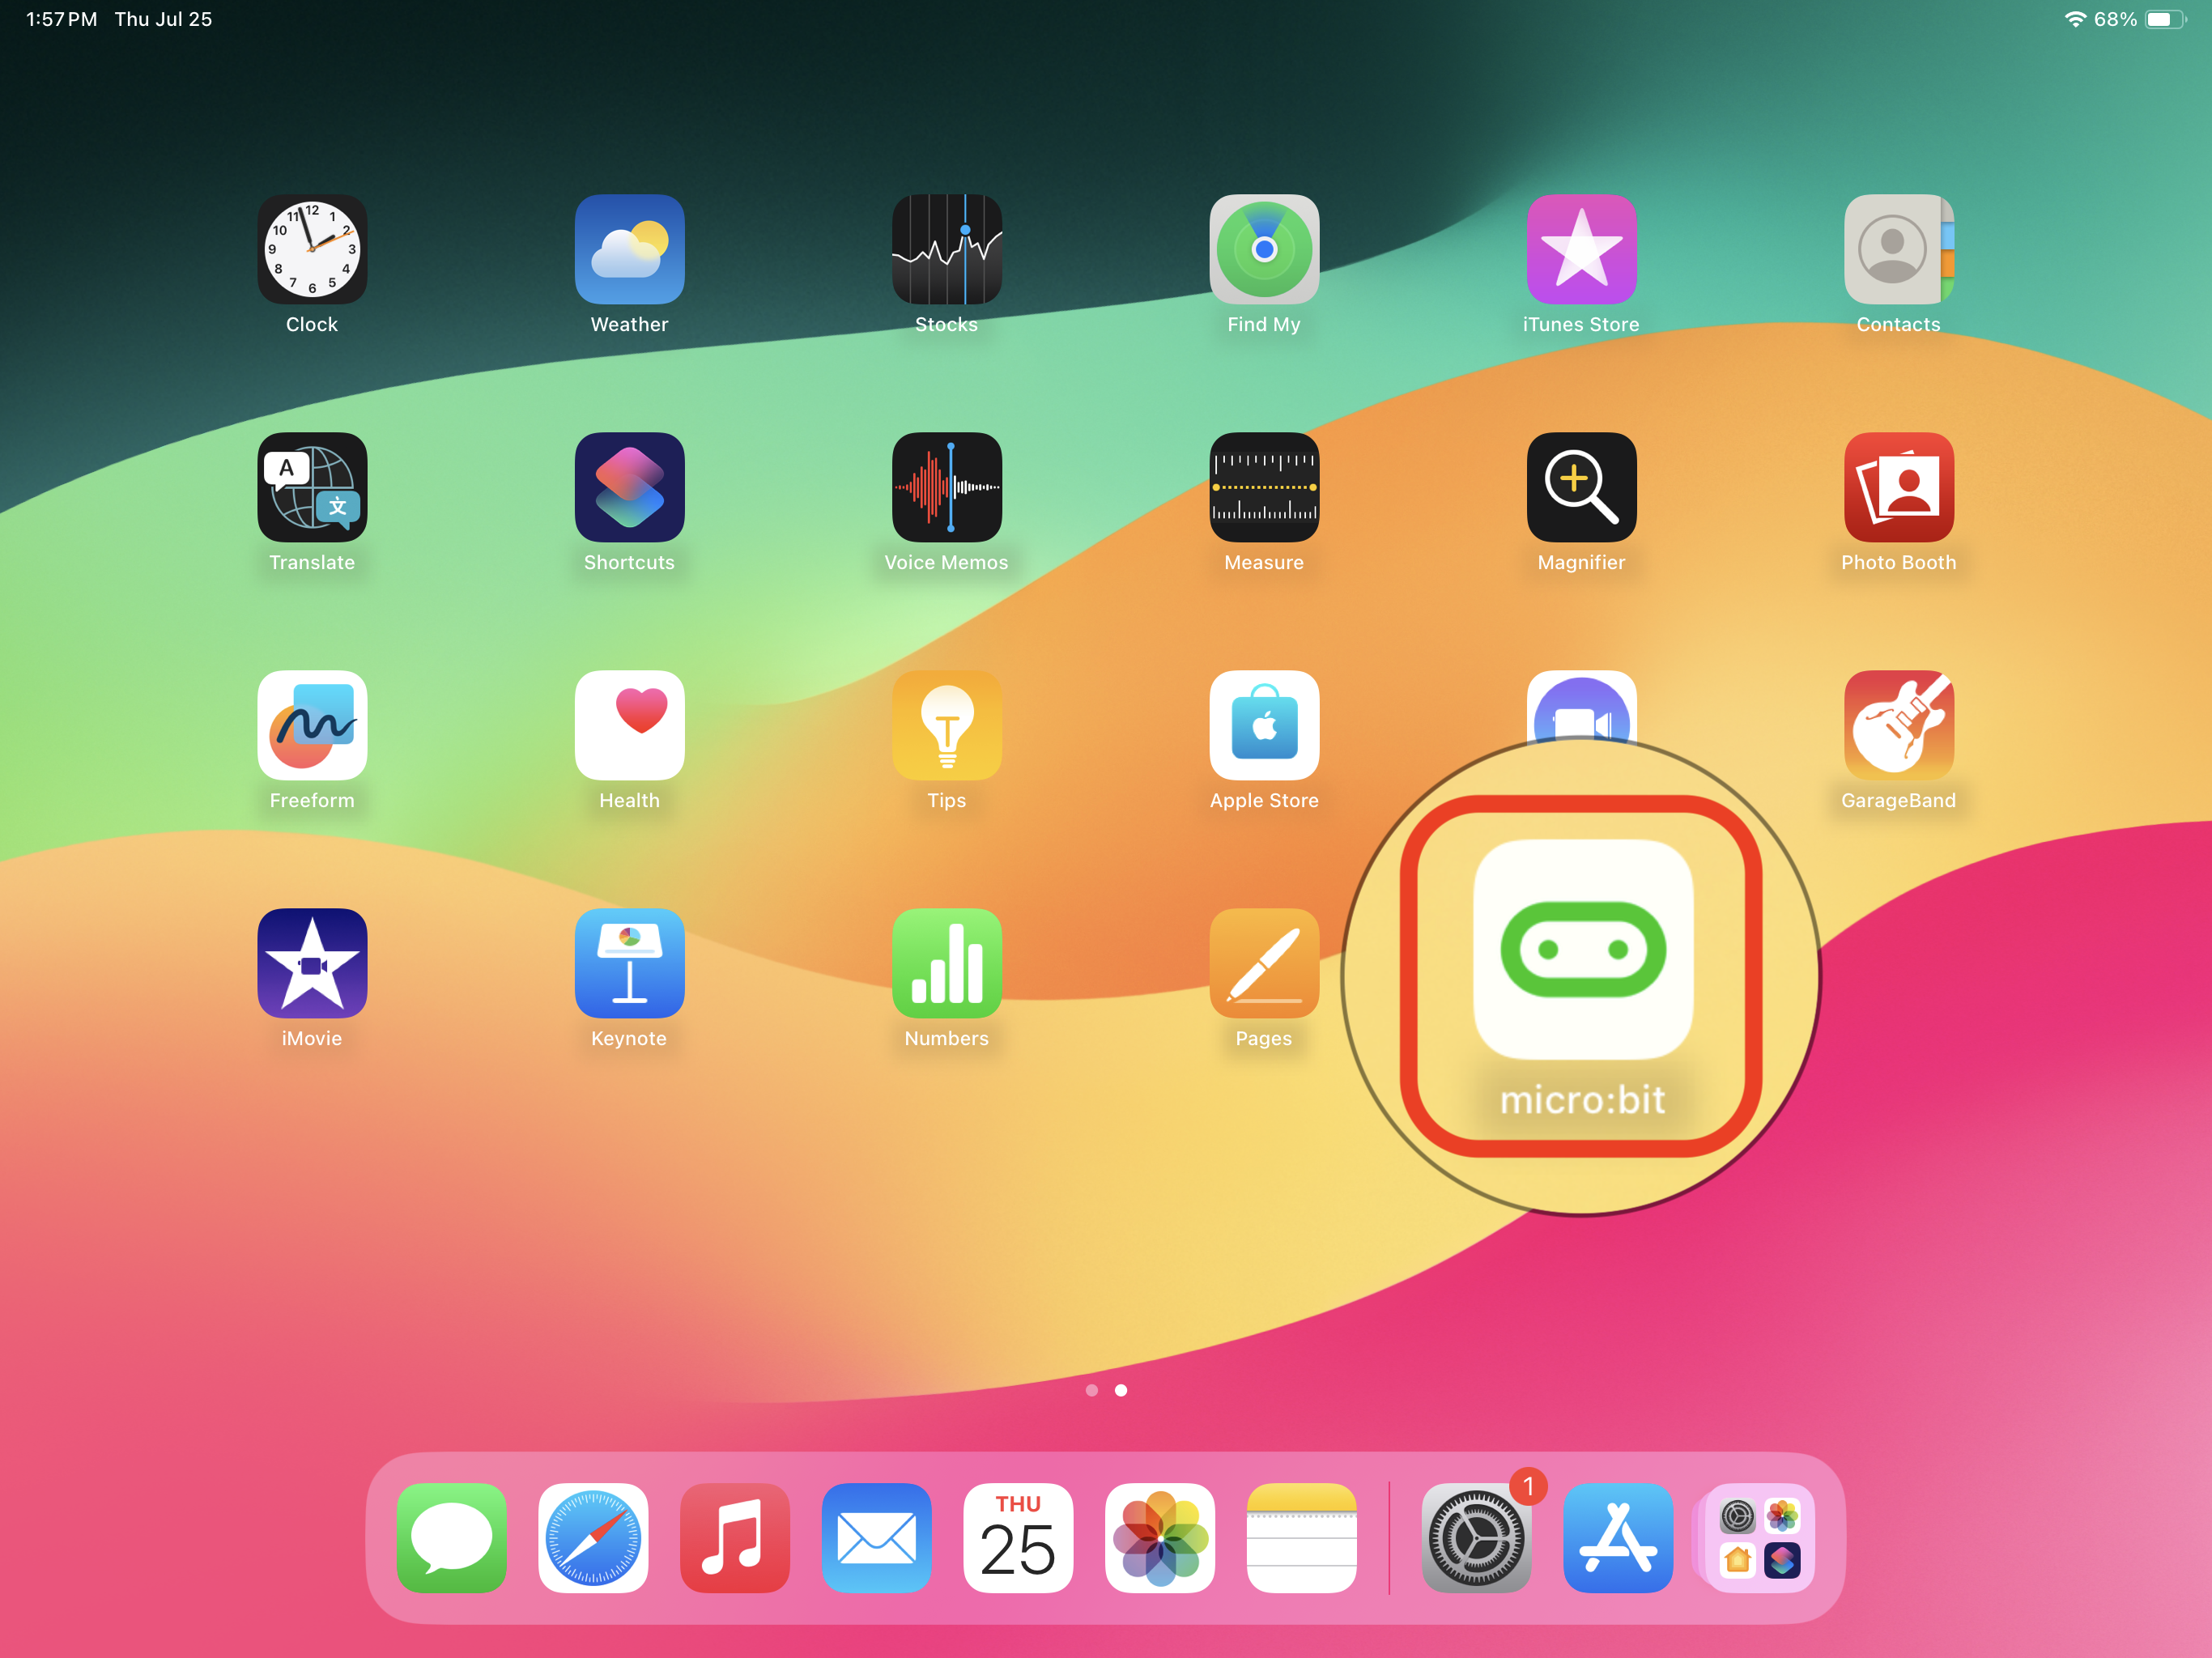
2. Allow the micro:bit to use Bluetooth  
   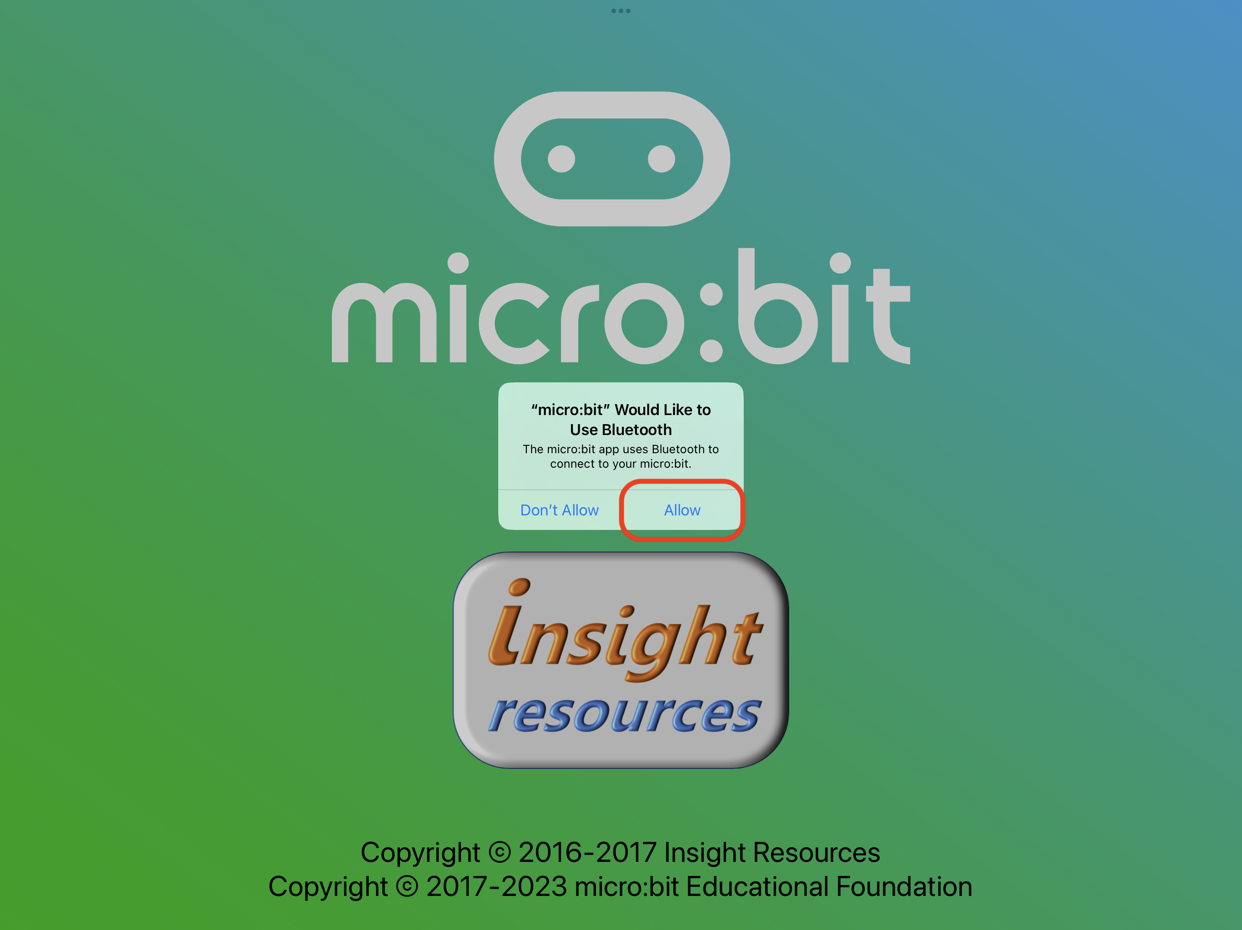
3. Ensure your Micro:bit has power. You can either connect it to a power source using the USB cable or use the battery pack.
4. Select 'Manage Connections' from the menu.  
   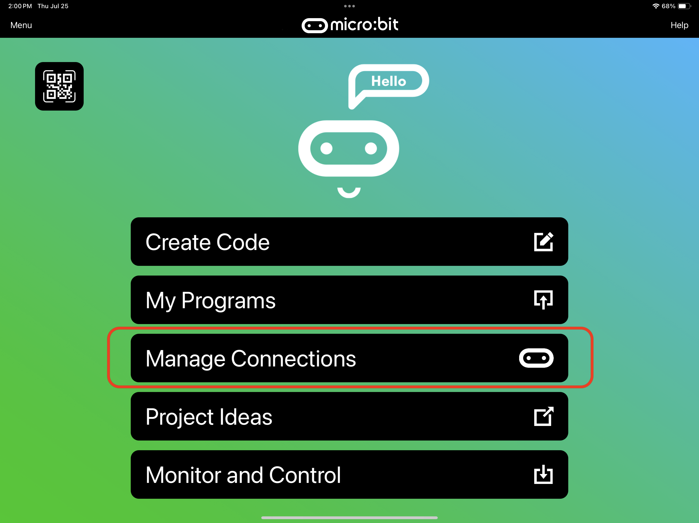
5. Follow the on-screen instructions to pair your Micro:bit with your iPad. You may need to press the 'Pair' button on the app and then hold down the 'A' and 'B' buttons on the Micro:bit while pressing and releasing the 'RESET' button on the back of the Micro:bit.

# Step 3: Create a Program

1. Once connected, tap the 'Create Code' button on the home screen of the app.  
2. Choose your preferred editor: MakeCode is recommended for block-based programming.  
3. The editor will open in this app.  
4. Start creating your program using the drag-and-drop blocks or JavaScript.

# Step 4: Download the Program

1. After creating your program, tap the 'Download' button in the MakeCode editor.  
2. The program will be compiled and downloaded as a .hex file.

# Step 5: Transfer the Program to the Micro:bit

1. After the Download is finished, it will automatically open a page to transfer the program, starting with reset micro:bit to Bluetooth mode  
   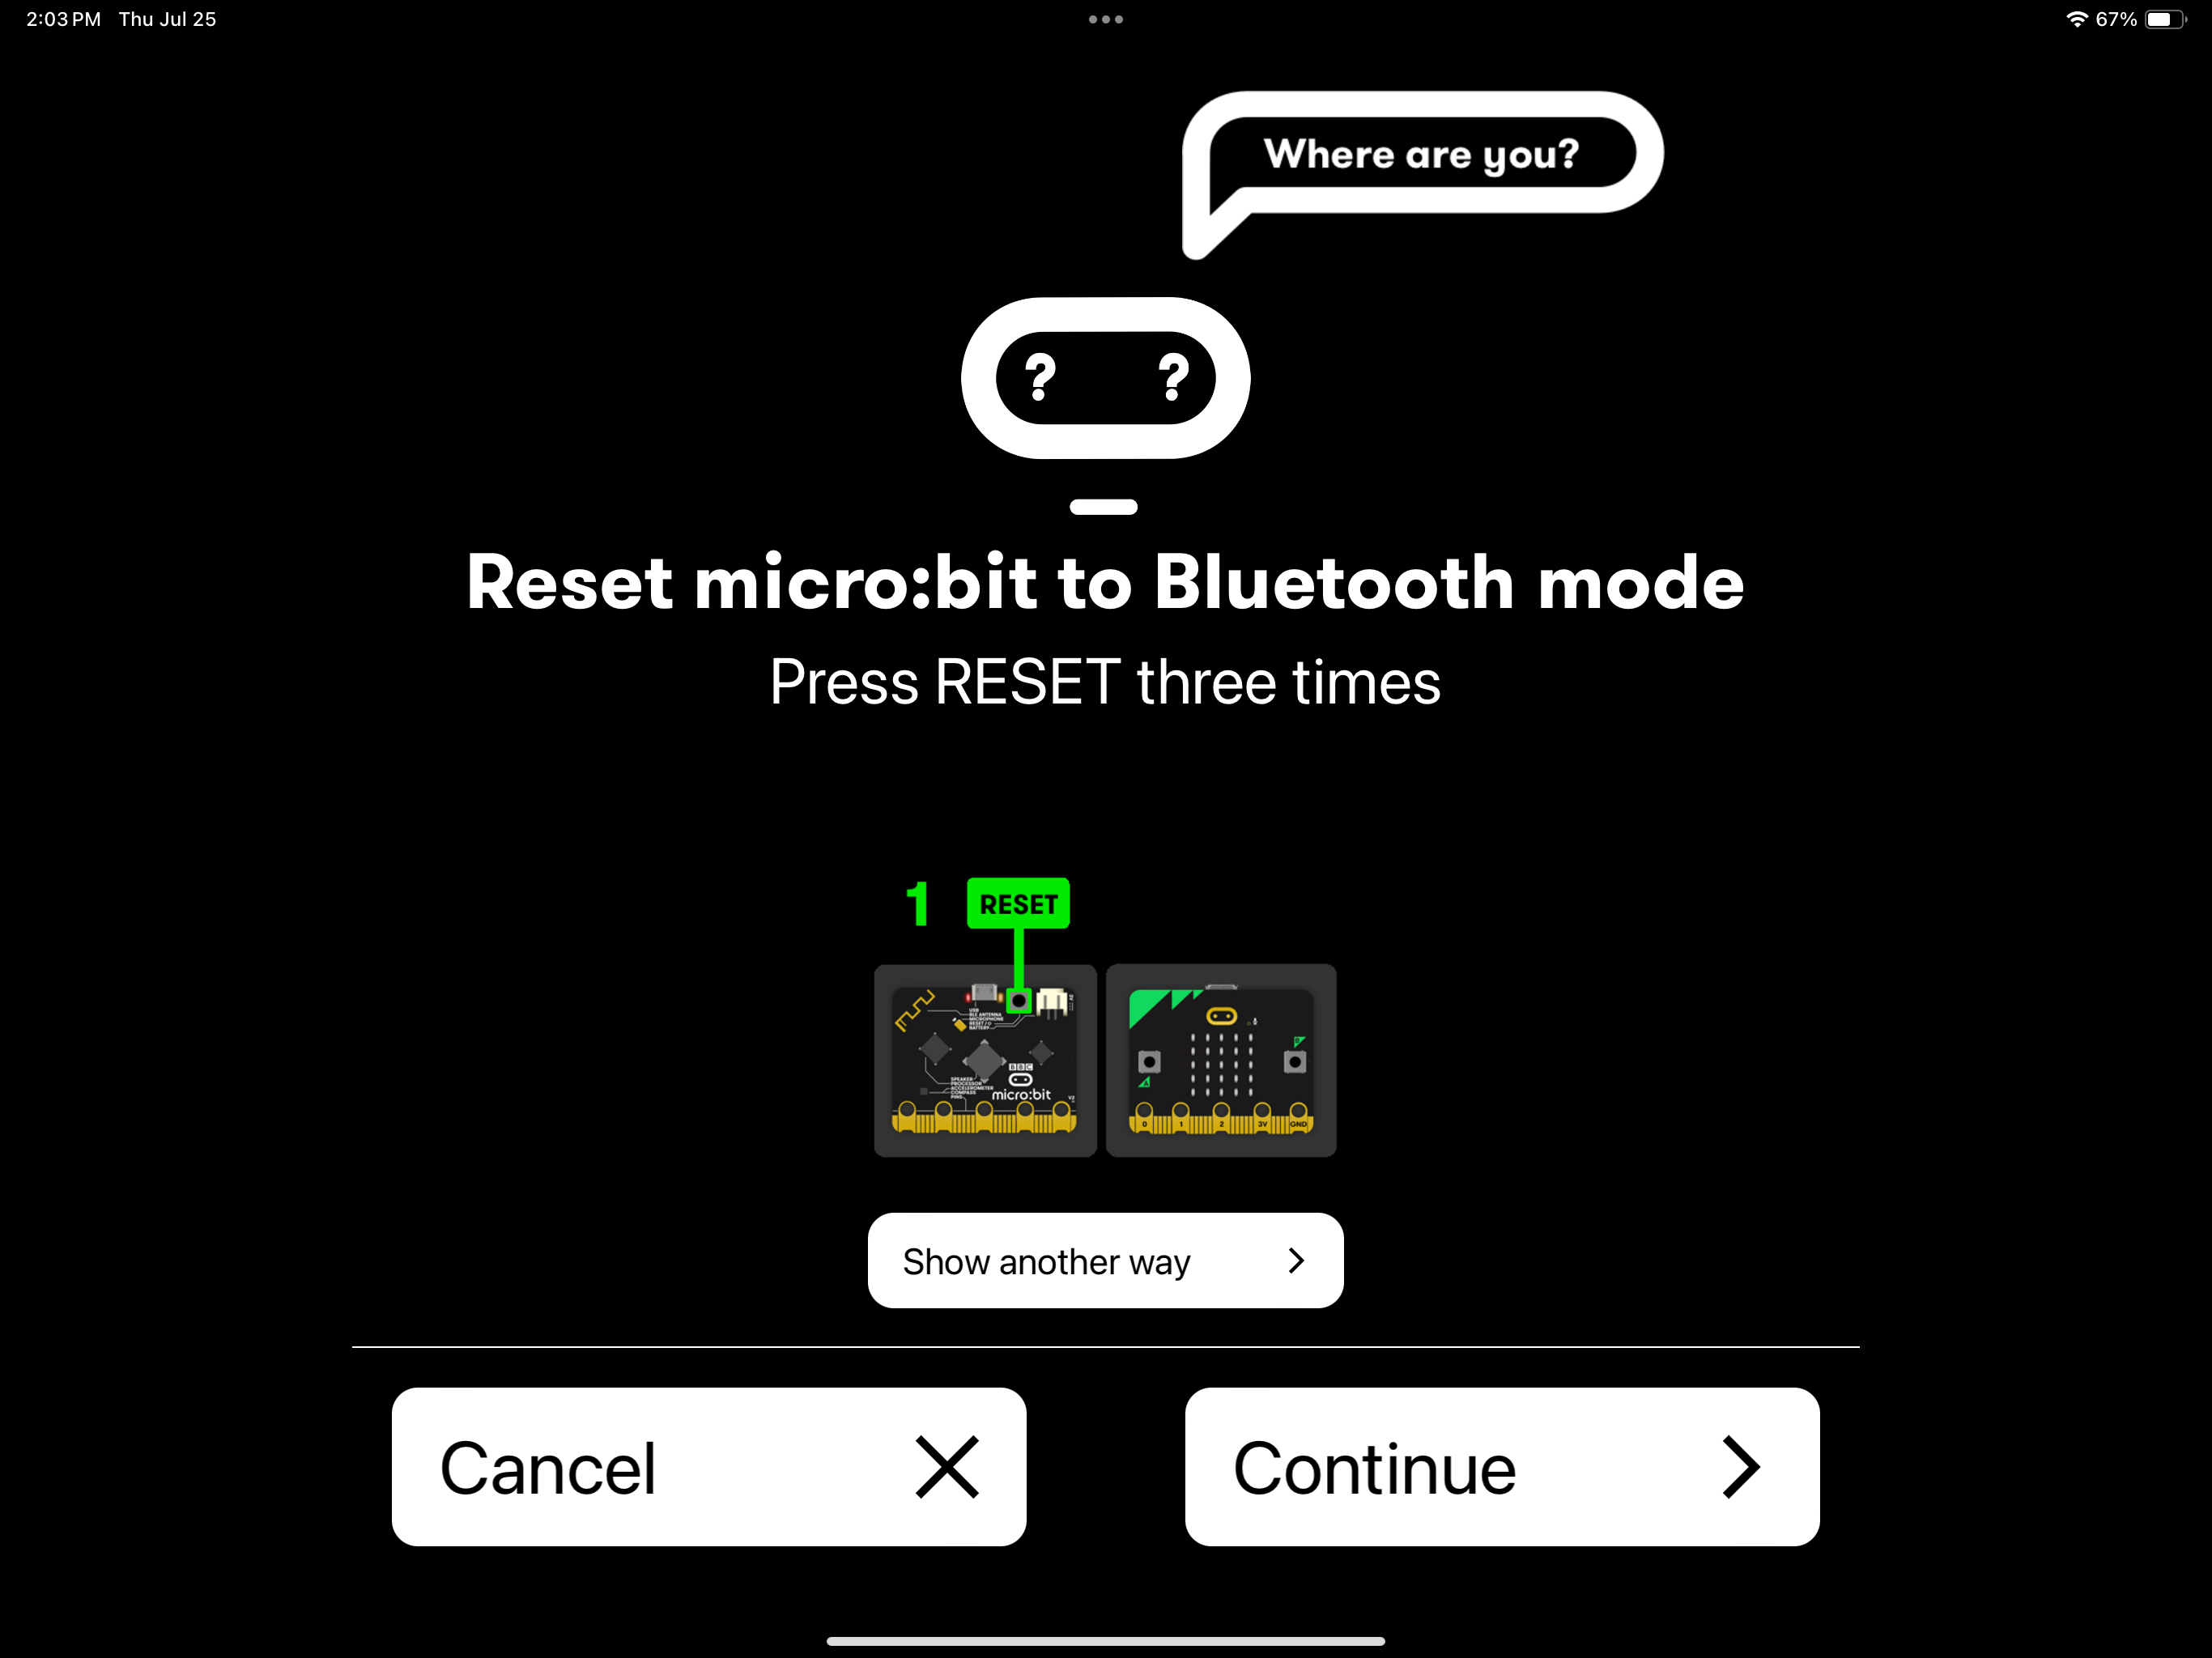
2. Ensure your Micro:bit has power. You can either connect it to a power source using the USB cable or use the battery pack.
3. Following the instruction on the screen.

# Step 6: Run Your Program

1. Once the transfer is complete, the Micro:bit will automatically start running your program.  
   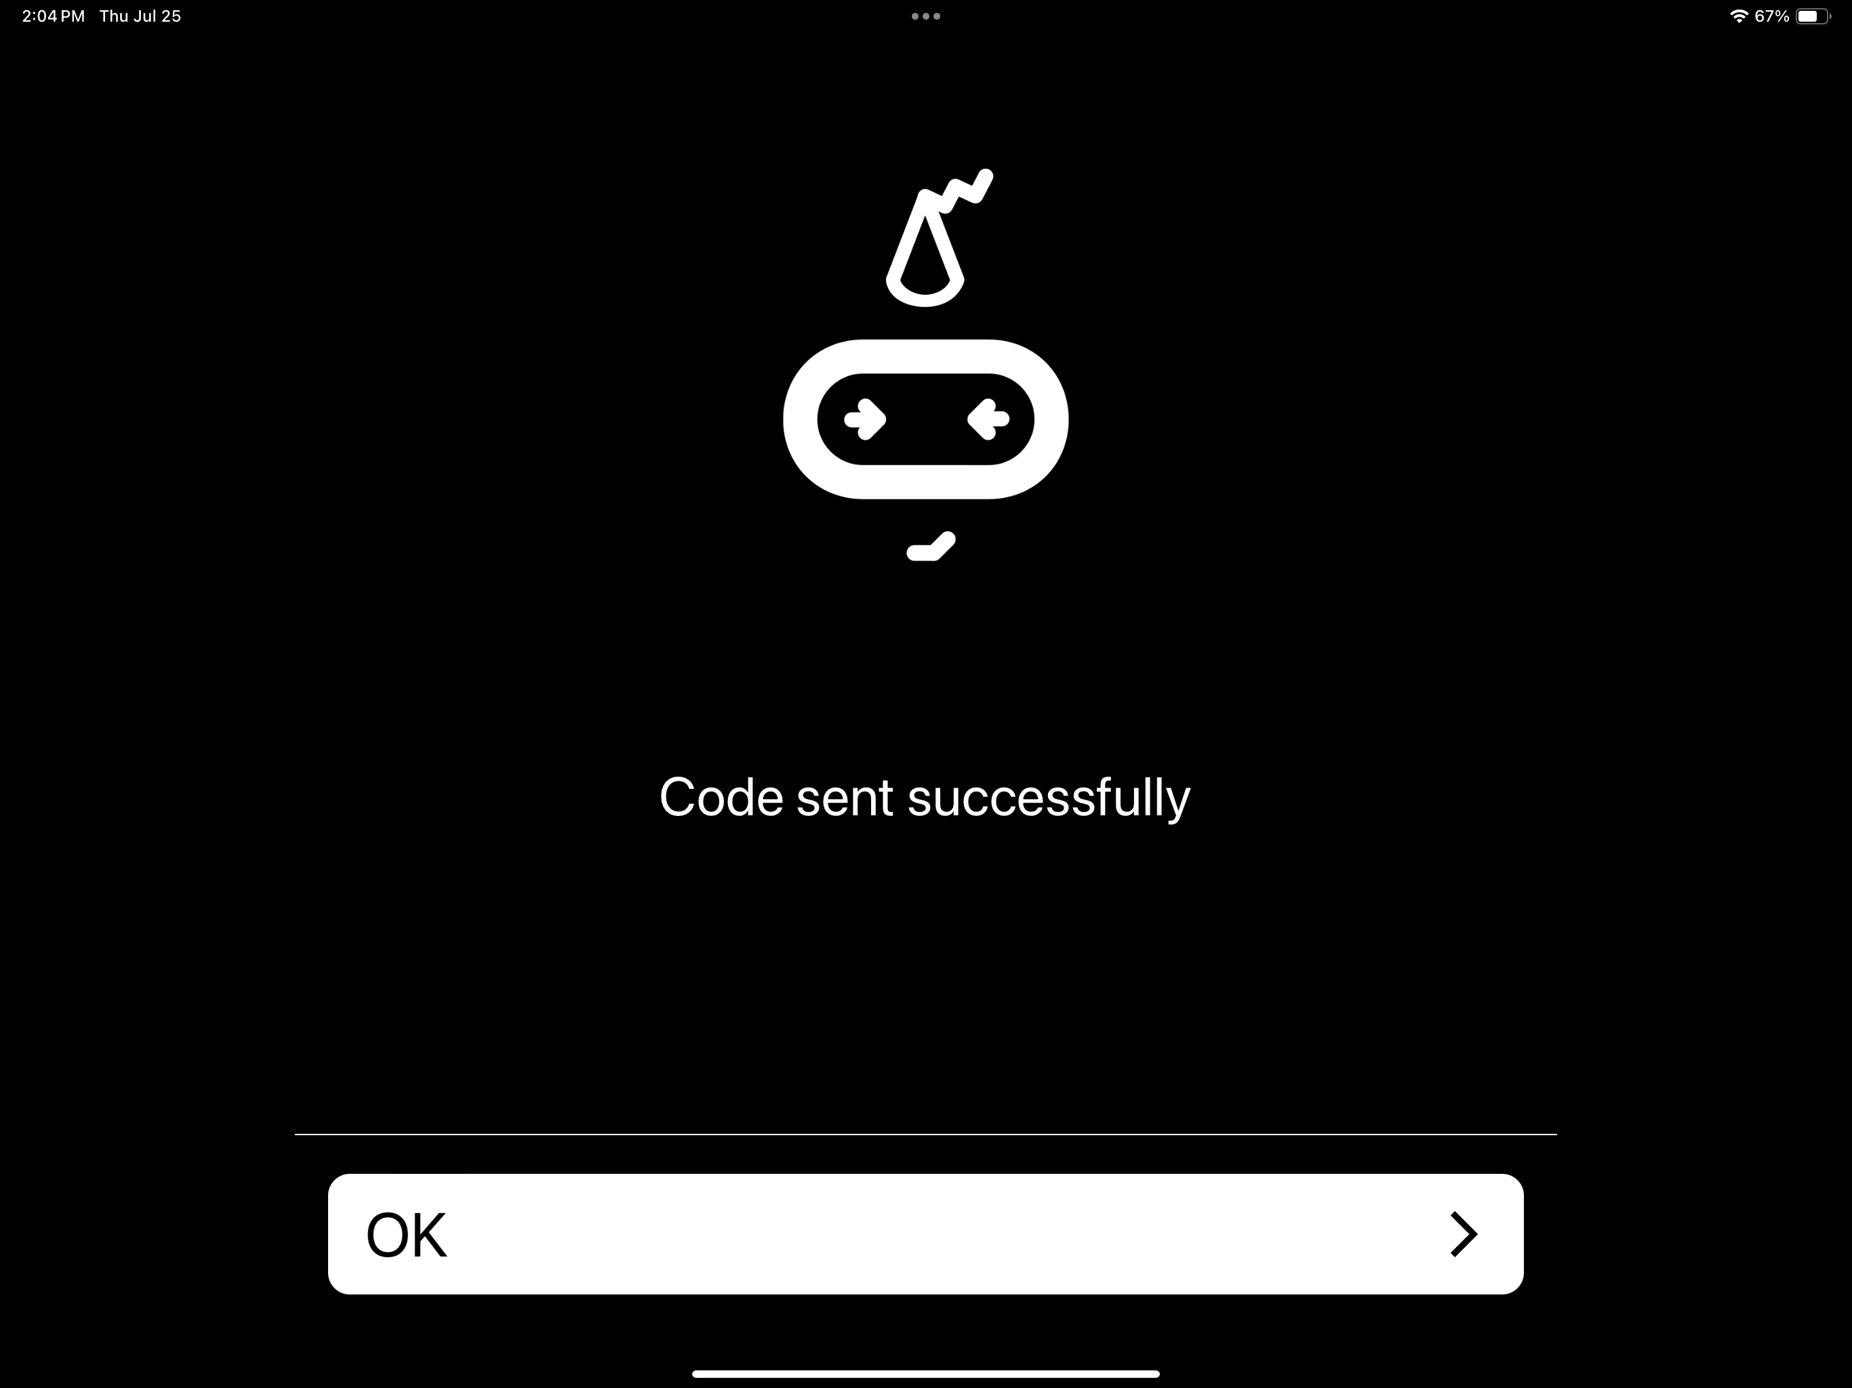
2. You can test and observe the behavior of the Micro:bit according to your program.

# Troubleshooting Tips

Ensure Bluetooth is enabled on your iPad.  
Make sure the Micro:bit is within a close range of your iPad for a stable connection.  
If the Micro:bit is not responding, try restarting both the Micro:bit and the Micro:bit app on your iPad.  
Check that the Micro:bit has sufficient power, especially if using the battery pack.